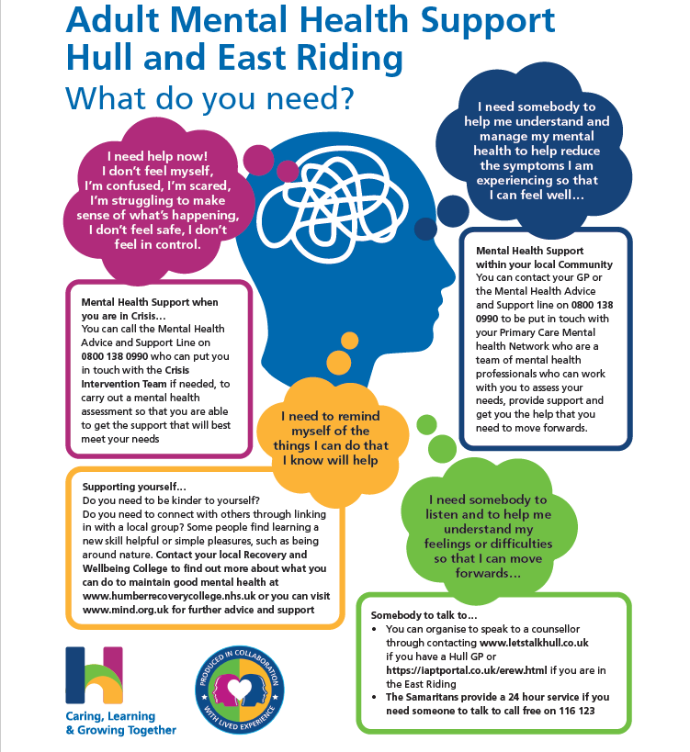

Adult Community Mental Health Services Brochure

Throughout this brochure you will find information about Humber Teaching NHS Foundation Trust and details about the Community Mental Health Services available to working age adults living in Hull and the East Riding of Yorkshire.
For information about Older Peoples Mental Health Services, you can find details on their webpage here: Older People's Mental Health Services (humber.nhs.uk)
If you would like further information about services at Humber Trust, please visit: Humber Teaching NHS Foundation Trust. Each service across the Trust also has an operational policy which provides detailed information about the role, function, and responsibilities of each team.
If you have any questions or if there is anything that you would like to discuss relating to our services, please contact the individual teams using the details provided within this brochure, or alternatively email HNF-TR.adultmentalhealthcaregroup@nhs.net

Hull and East Riding Community Mental Health Services

Across Hull and East Riding there are number of local Primary Care Mental Health Networks and Community Mental Health Teams working closely together to provide a range of support within local communities. They may provide support themselves, or through linking you in with a specialist team or with other groups and resources within your local community.

Community Mental Health services are designed to support the changing mental health needs of individuals. We understand that there are many factors that can impact upon mental health which means that there are times when our mental health is good and there may be times when we need more support for our mental health, regardless of whether we have a diagnosis or not.

Within our community mental health services, there is no ‘wrong door’. Wherever you arrive, you can be sure that we will work with you to help you get the support that best meets your needs. We aim to provide a range of support from GPs in Primary Care to our Primary Care Mental Health Networks and Community Mental Health Teams so that people can get the right support at the right time, preventing them from becoming more unwell.

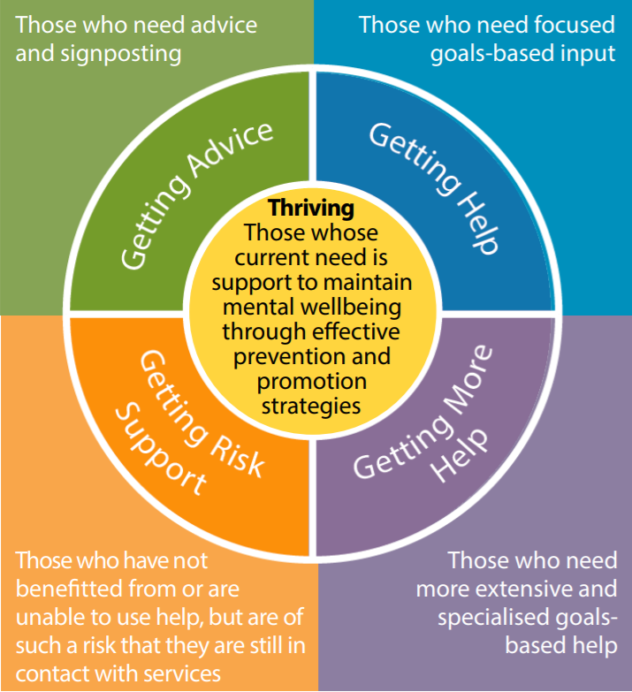
Community Mental Health Charter
Our Community Mental Health Charter was co-produced alongside those with lived experience of mental health difficulties and those working within Community Mental Health Services. It sets out our Key Values and Mission Statement across Hull and East Riding.

Primary Care Mental Health Networks (PCMHNs)
“The service actually listens to me. They don't judge at all. They take the time to understand a person.” (Service User, Cygnet Primary Care Mental Health Network)

“I was given very kind and understanding help with my mental health problems”
(Service User, Beverley Primary Care Mental Health Network)

Primary Care Mental Health Networks are small teams of specialist mental health professionals who are able to help you with your mental health difficulties. They are an extension of the local Community Mental Health Team and work in close partnership with your GP surgery and the Local Authority providing primary care mental health provision.

Following a visit to your GP, if mental health support is required for mild or moderate difficulties, your GP may refer you to Let’s Talk (Hull), the Emotional Wellbeing Service (East Riding) for talking therapies or to your local Primary Care Mental Health Network.
You can also self refer by calling the Mental Health advice and support line on 0800 138 0990.
Your local Primary Care Mental Health Network can provide…
- Advice
- Guidance
- Support
- Treatment
- Signposting

Following an initial assessment from a mental health professional, you and a member of staff from your local PCMHN will work together to decide what kind of support you might need. This could inlude being signposted to a specialist service or organisation within the community that can best meet your needs, or you may receive 12 weeks of targetted support from a mental health professional within the PCMHN.

Mental Health Professionals that provide support within the PCMHN are…

Peer Support Workers - Peer Support Workers are members of staff who are able to support others through drawing upon their own lived experience of mental health difficulties to provide support on your recovery journey.
“Just having someone nice who listened and seem like they care was the best thing for me. I had no idea the amount of clubs and activities that was near me before” (PCMHN Service User)
“Peer Support has been the most beneficial service she has accessed so far” (Family member of a person accessing the PCMHN)

Mental Health and Welbeing Coach - Mental Health and Welbeing Coaches use the ‘Recovery Star’ tool to look many aspects of a person’s life, including living skills, relationships, work, identity and self-esteem. Those using the service work together with the Mental Health and Wellbeing Coach to set their own personal goals within chosen areas and measure over time how far they are progressing towards these goals.
“She followed through with everything she said meaning I was able to trust her so she could support me. She offered me chance to reflect, suggest strategies, empowered me and listened to me” (Service User, PCMHN)

Mental Health Nurse - A registered Mental Health Nurse works closely with with GPs and other health professionals in the community, providing holistic assessments and developing recovery-focussed care plans with individuals, families, and carers. They also complete risk assessments and oversee medication issues.

Mental Health Social Worker - A Mental Heatlh Social Worker provides advice and support to individuals, families, and carers in line with the Care Act 2014. Social workers use relationship-based skills to help people to define and reach their own personal goals. They have particular roles in tackling stigma, discrimination and social exclusion. Social Workers use statutory knowledge to enable people to be safe from harm, live as independently as possible using strengths based practice.
“I can’t put what the Primary Care Mental Health Network has done. The Social Worker is worth her weight in gold. I can’t praise her enough” (Service User, PCMHN)

“She was easy to talk and she came to my home. That made a lot of difference as I’m house bound. Her coming and having a face to face… I can’t tell you how that made me feel. She got me a lot of help she was great” (Service User, PCMHN)

Pharmacists -Pharmacists and Pharmacy Technicians work with those using the service to review medication, provide information around medication and support those through changes in mediation to manage any side effects.
“The Pharmacist did something GPs haven’t done before -she listened to the exact symptoms and delved into when they were, the time of day and how I was feeling and she went away and researched into a particular type of depression that I was experiencing. She figured out I had Diurnal depression and she found the correct medication to fit that diagnosis” (Service User, PCMHN)
“The pharmacist sounded as though she really cared and it came across that this was not just a job for her” (Service User, PCMHN)

Making contact with your local Primary Care Mental Health Network
If you would like to make contact with your local Primary Care Mental Health Network for the first time, you can either contact your GP, or you can call the mental health advice and support line on 0800 1380990 to be referred. If you would like a re referral or are currently being supported through the Primary Care Mental Health Network, you can contact your local Community Mental Health Team who will be able to put you in touch with a member of staff from your local Primary Care Mental Health Network. (See CMHT contact details below)

Community Mental Health Teams (CMHT)
Community Mental Health Teams across Hull and East Riding are focused on providing care and treatment for working age adults who are experiencing moderate to severe mental health problems. Those who require support from this service may be experiencing severe or long-standing mental health difficulties which are disrupting their everyday functioning.
The CMHTs work very closely with Primary Care Mental Health Networks, allowing flexible support that meets individual needs where individuals can step up from the PCMHN to the CMHT, from the CMHT back to the PCMHN or in and out of community mental health support, to reflect a person’s changing mental health support needs.
Adults who experience a psychotic episode for the first time will be seen by the Early Intervention in Psychosis team who specialise in this area. The team is known locally as PSYPHER and is based in Hull but also works across the East Riding.

What do we want to help people achieve?
Those using the service will be helped to learn how to manage or prevent relapse in their mental health and understand how to reduce any risks. All our interventions are focused on recovery to enable individuals to be as independent as possible and to live a fulfilling life.
The care offered is planned with those using the service and is tailored to their individual needs. We always promote the principles of choice, recovery, personalisation, and self-directed support. Care is reviewed and evaluated regularly with the named worker, the psychiatrist, GP, and anyone else involved in their care.
The CMHT’s aim is to meet the mental health needs of our community. The CMHT staff support the needs of individuals and their families or carers with complex mental health problems by working alongside members of the team in conjunction with health and social care staff.
Those who are accessing support through the CMHTs will be assigned a named worker to ensure the individual gets the right level of personalised care according to their needs.
All named workers will be able to provide a range of treatment and interventions for complex mental health needs and will carry out a detailed assessment of an individual’s needs, including possible risks, and help them identify goals which they want to work towards. Our staff can provide a range of evidence-based interventions depending on the needs of the individual. These interventions are based on the best clinical evidence and follow NICE (The National Institute for Health and Care Excellence) guidelines, which have been designed to meet the individual’s needs.
Care is reviewed and evaluated regularly with the care co-ordinator, the psychiatrist, GP, and anyone else involved.

What we offer
Care Co-ordination
Your care will be co-ordinated by a named worker allocated to you who is responsible for ensuring your needs are met in line with Care Planning meetings, which may also be called Care Programme Approach (CPA) meetings or Person-Centred Care Planning (PCCP) as it replaces CPA in the near future - and everyone will be allocated a named worker. This role was previously carried out by a care co-ordinator.
The named worker supports the individual and their family or carers and assists them during their time with the service and may provide some interventions or also oversee the elements of care delivered by other practitioners, ensuring effective communication between all parties. They provide a main point of contact for the individual and their family or carer and is responsible for undertaking and sharing risk assessment and risk management plans with all those involved. This person could be a community mental health nurse, social worker, occupational therapist or care officer or other staff member.

Family Therapy/Family Interventions (sometimes known as Systemic Psychotherapy)
These are research informed, strengths based psychological therapies. They use the personal experiences and knowledge that individuals, couples and their families have about themselves and each other to help make sense of difficulties and challenges and find new ways to move on.
When someone experiences a severe mental health problem it affects the whole family, and these approaches to treatment include and support all family members.
Sessions can include anybody that the person receiving support thinks would be helpful to involve in discussions. Connection with the person’s care co-ordinator is maintained throughout the treatment process so that treatment provided is ‘joined up’ and consistent. Ask your named worker for more information or see here for further details Family Therapy and Family Interventions (humber.nhs.uk).

Family Inclusive Care Co-ordination
Mental health problems do not just affect individuals. They can have an impact on the entire family. Families have a unique and in-depth understanding and knowledge of their loved one’s difficulties, as well as their strengths and abilities. We are committed to working in partnership with families and carers and view families as a vital part of the care team.
All families and individuals will initially be invited to contact meetings with their family member’s named worker. The function of these meetings is for everybody to get to know each other and to listen to everybody’s point of view. The meetings explain how mental health services work and how decisions are made.
These meetings then take place at regular intervals. They help provide a consistent and transparent service, with everyone working together towards agreed goals. The meetings can help to relieve any anxieties and reduce risks as well as to support best outcomes for those involved.

Who works in the CMHT?

Care Officers - Care officers provide a range of social care interventions and care co-ordination as part of a multi-disciplinary team. In the East Riding the CMHTs work in partnership with social workers from East Riding of Yorkshire Council.
Clinical Associate Psychologists – Can provide and deliver psychological assessment and formulation in a person’s care journey and provide a range of evidence based psychological interventions under the supervision of a registered clinical psychologist.
Community Mental Health Nurses/Nurse Associates - Registered nurses who work in the community as part of the team, community mental health nurses work closely with GPs and other health professionals, providing holistic assessments and developing recovery-focussed care plans with individuals, families, and carers. They also complete risk assessments and oversee medication issues.
Mental Health Wellbeing Practitioners East Riding Only - This is a newly developing role to deliver effective evidence-based wellbeing interventions (but not therapy) to help people recover and live fulfilling lives and this will include the following Psychological Interventions:
a. Behavioural activation and graded exposure using the ‘GOALS’ programme
b. Problem-solving
c. Improving sleep
d. Recognising and managing emotions
e. Guided self-help for bulimia and binge-eating
f. Confidence building
g. Support with managing medicines management
Occupational Therapist (OT) - Occupational Therapists work with individuals with mental health problems to help them complete everyday tasks. They support the individual in maintaining a meaningful day-to-day routine. These routines give the individual a daily structure, creating a sense of purpose and direction to life. Meaningful activity and occupation therapy is essential for good mental health and wellbeing.
OT Assistant/Technical Instructor - Occupational therapy technical assistants work with Occupational Therapists in helping them assess and treat individuals in hospitals or in their own homes. This could include planning a daily routine for someone with mental health issues.
Pharmacist/Pharmacy Technicians - Working with those using the service to review medication, provide information around medication and support those through changes in mediation to manage any side effects.
Psychiatrist - A psychiatrist is a doctor who specialises in the care and treatment of mental health. A psychiatrist works in a team of health and social care professionals to assess, diagnose, and treat individuals who have been referred.
Psychologist - A clinical or counselling psychologist is a psychology doctor whose role is to support the team by delivering evidence-based care. This involves formulating and planning individualised care, providing psychological assessments and therapy, providing consultations and supervision, supporting training, and undertaking research.
Social Worker - A social worker provides advice and support to individuals, families, and carers in line with the Care Act 2014. They work in the team to promote recovery and take a lead supporting individuals with personalised support planning and personal budgets. Social workers assess and review situations to protect adults and children from harm.
Peer Support Workers - Peer Support Workers are members of staff who are able to support others through drawing upon their own lived experience of mental health difficulties to provide support on an individuals recovery journey.
Support Workers/Support Time and Recovery - This team provides support to individuals with mental health needs to help their recovery through activities in their communities. The worker helps the individual to achieve the care plan and liaises with the named worker to evaluate care for everyone.

How to access your local Community Mental Health Team (CMHT)
There are two main ways that you can access support from a Community Mental Health Team.
- If you are not currently being supported by your local CMHT, please contact the Mental Health Advice and Support Line on 0800 138 0990 to discuss a referral.
- Your GP or other professional support can refer you for an assessment using pathways available to them.
If you are experiencing a mental health crisis, the advice and support line is available 24 hours a day for anyone in Hull and the East Riding of Yorkshire area who requires information, advice and support with their mental health. You can also contact this line if you are worried about family or friends who may be struggling with their mental health. Call 0800 138 0990.

Contacting your local Community Mental Health Team (CMHT)
You should only contact your local Community Mental Health Team directly if you are already receiving support through the team. This is to ensure that you receive support that best meets your needs. If you are not currently being supported by your local CMHT, please contact the Mental Health Advice and Support Line on 0800 138 0990 to discuss a referral.

If you are currently being supported by your local CMHT and need to speak to a member of the team, please call using the contact details below.

Hull
West Hull CMHT, Waterloo Centre, 01482 335710
East Hull CMHT, The Grange, 01482 303740

East Riding
Bridlington CMHT, Crystal Villas, 01262 401292
Driffield CMHT, Market Place, 01377 208370
Goole CMHT, Bartholomew House, 01405 608220
Beverley CMHT, Beverley Health Centre and College House, 01482 344460
Haltemprice CMHT, Anlaby Clinic and College House, 01482 335959
Holderness CMHT, Rosedale Community Unit, 01482 344400

Other Community Mental Health Services
The Primary Care Mental Health Networks and Community Mental Health Teams may work alongside or signpost individuals to other specialist community mental health services working within the community.

PSYPHER - an early intervention in psychosis service that supports 14 - 65-year-olds who are experiencing first episode psychosis. Psychosis is a mental health problem that causes people to perceive or interpret things differently from those around them. About 1 in 100 people may experience an episode of psychosis, however many more people will have experiences of hearing voices or having beliefs that others do not. For many people, these experiences may be a normal part of life. PSYPHER aims to work with people and families who are distressed by experiences of Psychosis.
More details for this service can be found here: PSYPHER - Psychosis Service for People in Hull and East Riding (humber.nhs.uk)
PSYPHER 01482 336786

Specialist Psychotherapy Services (SPS)- The Specialist Psychotherapy Service sits within our wider Complex Intervention Service (CIS) and provides a range of psychotherapies that are informed by psychoanalysis.
Psychoanalytically-informed psychotherapy can help people with a wide range of difficulties including relational difficulties, anxiety, depression, emotional dysregulation, post-traumatic stress disorder and complex trauma.
This type of therapy explores the deeper meaning of psychological and relational problems with a view to increasing understanding.
SPS provides individual and group psychotherapy which can be longer or shorter in duration.
The team sees people aged 18 and above across Hull and East Riding who are experiencing severe, complex and longstanding psychological difficulties.
More details for this service can be found here: Specialist Psychotherapy Service (humber.nhs.uk)

Humber Traumatic Stress Service (HTSS)- The Humber Traumatic Stress Service sits within our wider complex intervention service (CIS) and offers specialist psychological assessment, formulation and therapeutic intervention for people residing in Hull who have experienced psychological trauma in their adult life.
HTSS also offers this service to Veterans from Hull and East Riding where their trauma is related to military service.
HTSS provides consultation and training to other professionals and services.
The team is comprised of clinical psychologists and an occupational therapist.
More details for this service can be found here: Traumatic Stress Service (humber.nhs.uk)

Dialectical Behaviour Therapy (DBT) - DBT is an evidence-based treatment for those with a diagnosis of borderline personality disorder. DBT is also helpful for people who self-harm and have suicidal thoughts. DBT combines individual therapy, group skills training and telephone coaching to help individuals to learn ways to tolerate distress, regulate emotions, be effective in relationships and be mindful. The main goal of DBT is to help individuals build a life worth living.
Our service provides a person-centred approach which advises on appropriate treatment, information, care, and support to empowers individuals with complex mental health difficulties and their carers to make informed decisions about care which help maximise quality of life. Interventions are time-limited and may include:
- Individual therapy
- Group therapy
- Occupational therapy
- Medication support
- Rebuilding self-esteem, support with coping and confidence skills and symptom control
- Provide expert risk formulation and robust risk management plans that are person-centred and family inclusive
- Family interventions
- Healthy living advice, including physical health screening, nutrition, and weight management.
Individuals may also be offered the opportunity to be involved in local and national research studies.
More details for this service can be found here: Humber Dialetical Behaviour Therapy

Department of Psychological Medicine - This department offers a range of specialist services, including:
- Hospital Mental Health Service (adult) – offering assessment of adults presenting with mental health problems in the acute hospital and in the emergency department
- General Liaison Team – offering assessment and psychological interventions to service users presenting to the acute hospital trust with medically unexplained symptoms, complex adjustment and psychological issues directly relating to physical health
- Perinatal Team – treating pregnant women and new mothers who have moderate to severe mental health problems
- Huntington's Disease Service – offering assessment and intervention to all service users with a diagnosis of Huntington's Disease
- Chronic Fatigue Service – offering diagnostic assessment and biopsychosocial interventions to adults presenting with symptoms of chronic fatigue syndrome.

Perinatal Mental Health Liaison Service
The Perinatal Mental Health Liaison Team covers Hull, East Riding, North Lincolnshire and North East Lincolnshire. It is a multidisciplinary service which aims to help women who experience moderate to severe and complex mental health problems related to the antenatal, labour and postnatal period. Where a woman has a previous serious mental illness, even if well at the time of referral we would look to work with her during the perinatal period.

We are committed to providing high quality care delivered in a timely and responsive manner to our local communities. In doing so we will also make the most effective and efficient use of resource.

In delivering the aspirations of ‘right care, in the right place at the right time’ we endeavour to keep waiting times and the numbers waiting for a service to a minimum.

If you feel you may require referral to the perinatal team, please speak to your health care professional.

For more information about mental health support in the antenatal, labour and postnatal period, please visit www.everymummatters.com or www.thedadpad.co.uk

Positive Assets
Do you feel that your mental health problems are a barrier to gaining employment? Do you live in Hull? If so, Positive Assets can help.
Most people who use mental health services want to work and are capable of working with the right support. However, they can face discrimination when applying for work. To challenge this discrimination, Humber Teaching NHS Foundation Trust has developed Positive Assets. This service encourages and supports individuals who live in Hull to formulate and achieve their vocational goals, with a focus on gaining and retaining sustainable employment within Humber Teaching NHS Foundation Trust and the public and private sectors.
With over 20 years’ combined experience in the field of vocational rehabilitation, Positive Assets is committed to helping people who experience mental ill health to gain and retain employment. Using the wealth of experience gained from working closely with mental health services, service users and local employers, Positive Assets is able to offer expert information, advice and training to local employers with regards to creating mentally healthy workplaces for all.
Positive Assets can:
• Help you find out about vacancies
• Support you to make job applications
• Prepare you for interview
• Help you with practical matters such as benefits, childcare etc.
• Provide ongoing support when in work
For more information contact the team on 01482 389227
or email HNF-TR.PositiveAssets@nhs.net

Group Programmes
Here are some examples of the types of groups we offer. This is not a full list. Please speak with the team in the area where you live to find out more.
The 12-week intervention programme is designed to take the first steps to assess the individual’s needs and to identify the types of intervention required. The sessions assist with symptom management by using evidence-based approaches such as Dialectical Behaviour Therapy and Cognitive Behavioural Therapy. This programme helps examine why individuals engage in self-destructive behaviours and teaches about emotions, mood and mindfulness. The group uses the recovery principles to further help understand an individual’s needs and to look at what they want to do in the future, helping them move into other groups or signposting them to other services.

MBT Service (Mentalisation-Based Treatment)
Mentalization-based therapy (MBT) is an evidence-based and NHS recommended treatment for people with a diagnosis of borderline personality disorder (BPD) and a range of other psychological difficulties. It is helpful for people who have long-term or complex problems, including difficulties in relationships, experiences of overwhelming and intense emotional distress, who might also engage in impulsive, self-destructive behaviour.
Our community MBT service comprises of a 12-week psychoeducational group which aims to discuss the principles of mentalization (the ability to think about thinking) to help an individual better understand their difficulties and develop basic mentalizing skills. Following this there is a review to consider next steps which may include progression to the yearlong MBT experiential group programme. This is more exploratory in nature and helps further develop the use of mentalizing. This comprises a weekly group alongside fortnightly individual MBT therapy sessions.
All referrals to the MBT service are made via the care-coordinator from the relevant community team.

Well-being sessions is a six-week group for those interested in healthy living. The group promotes awareness and enjoyment of a healthier lifestyle through education, open discussion and practical activities. We work in partnership with health trainers and also offer one-to-one appointments to assess the physical health of those individuals who have longer term mental health problems and take medication.
Community life skills group is designed to look at what is available in the local community regarding finances, benefits, leisure and entertainment. The group looks at working with and improving mental and physical health, such as using the gym, walking or joining activity groups. It works on improving independent living and travelling skills. One of the other areas of focus is on social interaction skills that create a sense of belonging and inclusion. The group sets weekly and future goals which enable individuals to achieve their full potential. It helps build self-esteem and confidence with the emphasis on relapse prevention using the recovery model.
Several creative groups are aimed at developing social interaction using art and creative programmes. There is clear evidence that being creative impacts on health and well-being through involvement in making art which:
- Increases self-confidence and self-esteem
- Allows individuals to do something they enjoy
- Improves levels of concentration and focus
- Gives meaning and purpose in life.
Creative groups support better social networks, enjoyment of social experiences, reduce isolation and increase educational opportunities. as well as promoting the physical health of service users with mental health problems.
The allotment group provides an opportunity to be outdoors and helps in learning new skills or rediscovering those long forgotten. The group provides structure, routine and a meaningful day. The group is aimed at building and supporting wellbeing and resilience as well as promoting the physical health of service users with mental health problems. The activities are adapted to suit all group members, interest levels and physical limitations. There is growing evidence to show that being in natural green spaces boosts wellbeing, self-esteem and confidence, while teaching new skills and allowing individuals to reconnect with their community, creating a sense of belonging.

The Recovery and Wellbeing College
Humber Recovery and Wellbeing College is a safe and supportive learning environment that aims to help people manage their own recovery journey. By building upon existing individual strengths and helping to develop skills and confidence in an educational setting, the college can help empower you in developing your independence. It is an NHS college which provides an opportunity to find a recovery-focussed course or activity that appeals to you whether that’s trying something new, building on existing skills or helping you manage your feelings and emotions.
The college is user led, emphasising hope, optimism and valuing inspirational aspirations and goals. Courses, which are developed through service user consultation, are led by passionate tutors and supported by volunteers and staff with lived experience.
The Recovery College aims to help you in three ways:
- Hope—that it is possible to work towards your own goals as defined by you
- Control— to regain control of your own symptoms and future
- Opportunity—to build a meaningful and satisfying life irrespective of your mental health difficulties
“I like the informal atmosphere and great people taking the course, and it helps having people with lived experience supporting you”
Some of our courses have included:
- Wellbeing Through Creativity
- Getting a good night’s sleep
- Coping with Emotions
- Work and Meaningful Activity
- Self-Esteem and Self-Compassion
“I think these workshops are great and really helpful for people with mental health difficulties to get together and communicate. The course was excellent and has helped me immensely in my recovery My confidence has grown and I feel able to join in and voice my opinions without feeling inadequate”
All courses and dates can be found in the latest prospectus, which it widely available throughout the Trust.
For more information and to access online learning courses, please visit https://humberrecoverycollege.nhs.uk/
Or you can contact the team on Telephone: 0800 917752 Email: HNF-TR.RecoveryCollege@nhs.net

Social Prescribing through Your Health Service - This a care approach that ‘connects people to activities, groups and services in their community to meet the practical, social and emotional needs that affect their health and wellbeing’ (NHS England).
Our Your Health Service delivers the social prescribing offers across Hull and the East Riding. Our professional team is made up of expert Health and Wellbeing Advisors and Connectors, who are equipped to refer you into support services that focus solely on what matters to you, to help you achieve your health and wellbeing goals.
It can help you take a holistic approach and empower you, when wanting to top up your own self-care. This can include both practical and emotional support.
When working with our friendly team, you can expect to develop a care plan which is tailored to you as an individual. This could include support on a whole range of topics such as employment, finances, carers, emotional wellbeing, welfare, cost of living, dementia, and more.
Anyone can seek social prescribing support, and when you do, you can expect to produce a personalised support plan together with the professional team, to help you reach your goals.
Social prescribing works well for people who:
- Have one or more long term conditions
- Who need support with low level mental health issues
- Who are lonely or isolated
- Who have complex social needs which affect their wellbeing
- Who have financial instability or are struggling with the cost-of-living crisis
- Who is caring for others
If you’re unsure if social prescribing is for you and you cannot make it to one of the team’s upcoming events, you can also contact the Your Health service today to find out more:
Website: www.nhs-health-trainers.co.uk
Phone: 0800 9177752

Other related services that you may come into contact within Hull and East Riding

The Mental Health Crisis Intervention Team is a 24-hours a day, seven days a week assessment service for adults over 18 in Hull and East Riding of Yorkshire. We provide non urgent assessments identified at point of triage and urgent assessments for those who are felt to be a risk to themselves and/or others - including risk of severe self-neglect - who are being considered for hospital admission and who require a same day assessment. The service also provides Home Based Treatment (HBT).
The Mental Health Advice and Support line is available 24 hours a day for anyone in Hull and the East Riding of Yorkshire area who requires information, advice and support with their mental health. You can also contact this line if you are worried about family or friends who may be struggling with their mental health. Call 0800 138 0990.

Inpatient units - providing assessment and treatment to adults of working age. The teams at Avondale, Newbridges, Mill View Court, Intensive Care Area (PICU) and Westlands work closely with the Mental Health Crisis Intervention Service and Home-Based Treatment teams.

Admission Process
The process for admission remains the same for all Inpatient Units. The pathway is broken down into stages so that staff may pick it up at any point during a person’s journey after ensuring all least restrictive options have been considered and the expectations of what the referral for an admission would achieve from the patient, family and professional perspective and the named worker if under the care of the community mental health team.
Patients often present with escalating needs in the days leading up to an admission. Should the needs of the patient become more intensive, or concerns are expressed by family/carers, it would be expected the for the key worker or duty clinician (if the key worker is unavailable) to contact the Home-Based Treatment Team (HBT) to discuss the escalating situation, following their own review of the patient and situation as it may be possible to offer increased support as an alternative to an admission.
A planned joint face to face review can be planned with the HBTT, CMHT, patient & family, in the coming days to determine a collaborative plan of care, identifying the least restrictive options first, but with parameters agreed for further escalation to admission if required. There may be more than one joint meeting which occurs during this time of increased need and acute presentation.
Referrals from other agencies such as GP/Housing/Prison services are managed via agreed pathways for those services.
Inpatient Units Contact Details

Avondale, 01482 617565
Newbridges, 01482 335834
Westlands, 01482 335645
Mill View Court, 01482 344537
Psychiatric Intensive Care Unit (PICU), 01482 617505

Waiting List Pledge
We aim to keep waiting times and the number of people waiting for a service to a minimum in line with national waiting time standards. Our guiding principle is that the interest of the individual is most important. We pledge to monitor waiting times closely to address any emerging problems and to act quickly to address them. Our teams will inform individuals on the waiting list of how long they can expect to wait and will provide them with the name of a staff member who will be a point of contact. You will be informed by letter if you have been placed on a waiting list and someone from the team will make contact with you at least fortnightly unless you indicate you want to be contacted less frequently until you can be allocated to a named worker.

Supporting you to move forward from community mental health services?
As part of recovery planning, those involved in your care will support individuals on their recovery journey, including managing moving on from support. Any move away from support provided by the CMHT will be discussed in a care review meeting with clinical staff, the individual and family members. Care co-ordinators work closely with local community services such as GPs, health and care agencies and support groups to ensure that individuals are supported through such transitions. Humber Trust has a range of opportunities to support individuals on their recovery journey through joining activities provided by the Recovery College, or through using your experiences to make positive changes to the services that Humber Trust provides through joining a co-production group.

Get Involved
Co-production and the involvement of those with lived experience in service development activities
At Humber Trust we believe that the experiences of our Patients, Service Users and Carers should be at the heart of our services. We strive for our services to be co-produced which means that those who use our services work alongside us, in partnership. Bringing together lived experience and the knowledge of those working in our services are what helps to get things right first time so that our services can best meet the needs of those that use them.
“The key difference between co-production and other forms of influence and participation is that, in co-production, people with lived experience play an equal role in both designing and delivering services, rather than making suggestions that professionals are responsible for deciding upon and implementing.”
Coproduction is more than asking people for their opinions and thoughts. it’s about empowering people to design, create and deliver quality, user-led initiatives for themselves. The role of staff is to offer professional expertise, support and guidance.
If you would like to use your lived experience of our services to get involved in helping to improve and develop our mental health services at Humber Trust, please contact hnf-tr.adultmentalhealthinvolvement@nhs.net or scan the QR code to be added to our Adult Mental Health Involvement Mailing list.
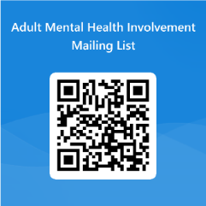

Feedback
We engage with individuals, families and carers who use our services to look at how we can improve their experience of CMHTs. The use of the Friends and Family Test (FFT) is available in all team bases and is offered to all service users.
We use a range of approved outcome measures, review service user feedback and promote positive service user experience to ensure systems are in place to monitor the quality of the services.
To provide feedback on our Community Mental Health Services at Humber Trust, please use the following link to complete a friends and families test survey using your services individual team code.
Friends and Family Test (humber.nhs.uk)

Research
The Humber Research Team offer people the opportunity to take part in local and national research studies. You might want to get involved in research to learn more about a condition that affects you, access treatments and support not yet available on the NHS or make a difference by helping to improve healthcare and quality of life, now and for future generations. There are many benefits of taking part in research. Research studies differ in their purpose and requirements. The Research Team will be available to support you throughout your participation. For more details see our co-produced animation ‘My Research Journey’ Humber Teaching NHS Foundation Trust - My Research Journey (English Subtitles) - YouTube
You can ask your doctor, nurse or healthcare professional about research studies that you may be suitable for. Or, you can visit the research section on the Humber website Research (humber.nhs.uk) and contact the Research Team directly.
We also offer opportunities for you to take part in shaping new research ideas and studies. You could become a Research Champion or be part of an advisory group on a study you have particular interest in. You can also learn more by signing up to access the Research module of the Patient and Care Experience (PACE) online course on the Humber Recovery College website NHS Humber Recovery and Wellbeing College (humberrecoverycollege.nhs.uk).
“Research gave me the hope I so desperately needed”
“Knowing that the research may be used to help other people can feel really empowering”
For more information on what the Research Team offer and how you can be part of the future of mental health care please get in touch.
01482 301726
Hnf-tr.researchteam@nhs.net
@ResearchHumber
www.humber.nhs.uk/Services/research.htm

Contact Details
The advice and support line is available 24 hours a day for anyone in Hull and the East Riding of Yorkshire area who requires information, advice and support with their mental health. You can also contact this line if you are worried about family or friends who may be struggling with their mental health. Call 0800 138 0990.

Primary Care Mental Health Networks
If you would like to make contact with your local Primary Care Mental Health Network for the first time, you can either contact your GP, or you can call the mental health advice and support line on 0800 1380990 to be referred. If you would like a re referral or are currently being supported through the Primary Care Mental Health Network, you can contact your local Community Mental Health Team who will be able to put you in touch with a member of staff from your local Primary Care Mental Health Network.

Community Mental Health Teams (CMHT)
Hull
West Hull CMHT, Waterloo Centre, 01482 335710
East Hull CMHT, The Grange, 01482 303740
Early Intervention in Psychosis team (PSYPHER), Townend Court, 01482 336786

East Riding
Bridlington CMHT, Crystal Villas, 01262 401292
Driffield CMHT, Market Place, 01377 208370
Goole CMHT, Bartholomew House, 01405 608220
Beverley CMHT, Beverley Health Centre and College House, 01482 344460
Haltemprice CMHT, Anlaby Clinic and College House, 01482 335959
Holderness CMHT, Rosedale Community Unit, 01482 344400

Inpatient units

Avondale, 01482 617565
Newbridges, 01482 335834
Westlands, 01482 335645
Mill View Court, 01482 344537
Psychiatric Intensive Care Unit (PICU), 01482 617505

Humber Teaching NHS Foundation Trust Headquarters
Humber Teaching NHS Foundation Trust HQ, Willerby Hill, Beverley Road, Willerby, HU10 6ED, 01482 301700

Complaints and Feedback Team
The Complaints and Feedback team is here to listen, in confidence, to any concerns or comments you may have about the care you or someone you care for is receiving. They can provide advice and guidance on the complaints process. If you wish to make a complaint and are not the patient, signed consent will be sought from the patient before the Trust can proceed with your complaint.
The team can be contacted on 01482 303930 or you can Email: HNF-TR.complaints@nhs.net

Bridgit Care App
The Bridget Care App provides information about health conditions, local events, and services. Click the link below for more information.
https://bridgit.care/support/humber?t=mhbrochure

Other Support Services

Click here for a list of other useful services - Support Services for you (humber.nhs.uk)
Let’s Talk, Hull, call 01482 247111 or to book your assessment appointment online use www.letstalkhull.co.uk or text TALK to 61825 .
Emotional Wellbeing Service, East Riding, call 01482 335451
Samaritans http://www.samaritans.org/ or Tel: 116 123
MIND http://heymind.org.uk/ or Tel: 0800 138 0990
Hull and East Yorkshire MIND, www.heymind.org.uk, 01482 240200
Crisis - Mental Health Crisis Intervention Team (humber.nhs.uk) or Support for adults experiencing a mental health crisis or urgent care need (humber.nhs.uk)
Carers Centre Hull, www.carersuk.org, 01482 225078
Rethink Carers Centre, www.rethink.org, 01482 679723
Healthwatch, Hull, 01482 499038
Healthwatch, East Riding, 01482 334999
Home Based Treatment, 01482 336699

Humbercare, www.humbercare.org.uk, 01482 586633
Hull City Council, www.hull.gov.uk, 01482 300300
East Riding of Yorkshire Council, www.eastriding.gov.uk, 01482 880460

Privacy Policy

Humber Teaching NHS Foundation Trust collects, stores and uses large amounts of personal data every day, such as medical records, personal records and computerised information. This data is used by many people in the course of their work.

Humber Teaching NHS Foundation Trust is the data controller of the personal data and is responsible for complying with data protection legislation.

We take our duty to protect your personal information and confidentiality very seriously and we are committed to taking all reasonable measures to ensure the confidentiality and security of personal data for which we are responsible, whether computerised or on paper.

The Privacy Notice explains how we may use your information - Patient Privacy Notice - full text.pdf (humber.nhs.uk)

